1. Junit UndoManagerFactoryImplTest

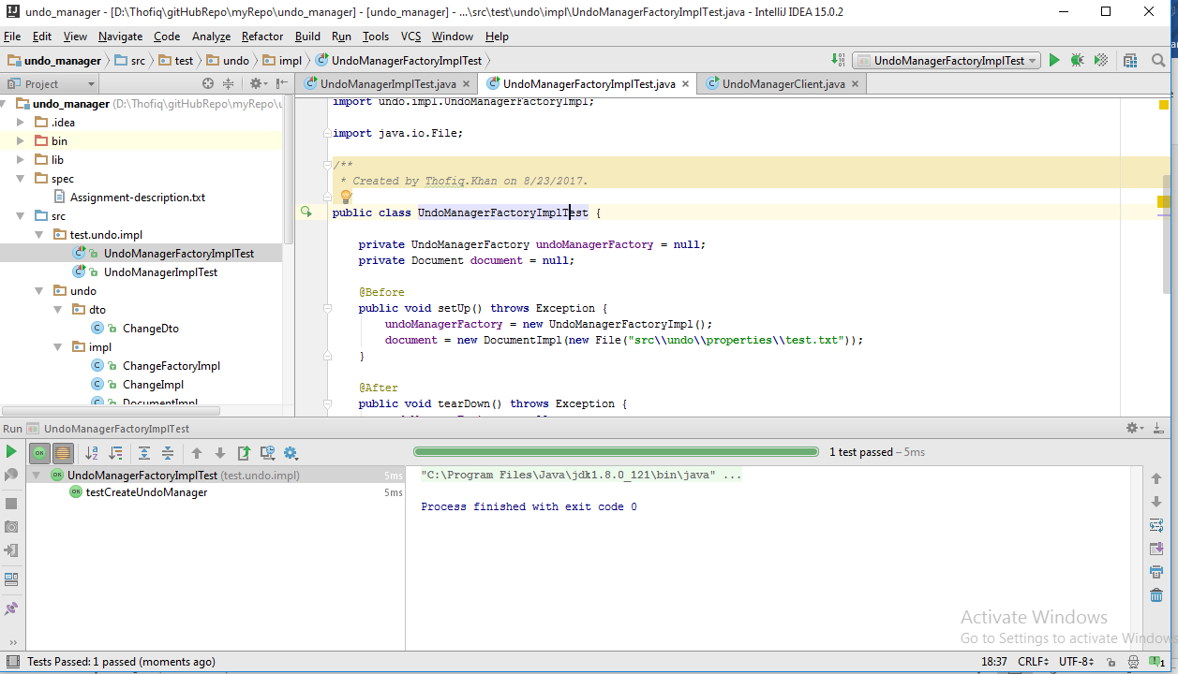

1. Junit UndoManagerImplTest

